JDBC LAB-2

Prajwal_77

Create a program to perform CRUD operation for student [ rno,name,marks,date of birth ] using  
PreparedStatement. Take values from keyboard.

*package* nov17;  
*import* java.sql.*Connection*;  
*import* java.sql.DriverManager;  
*import* java.sql.*PreparedStatement*;  
*import* java.sql.SQLException;  
  
  
*public class* StudentDemo {  
  
  
 *public static void* main(String[] args) {  
  
  
 *try* {  
  
 Class.*forName*("com.mysql.cj.jdbc.Driver");  
  
  
 *Connection* con = DriverManager.*getConnection*("jdbc:mysql://localhost:3306/java", "root", "Prajwal@123");  
  
  
 *PreparedStatement* s = con.prepareStatement("create table student2(rno int primary key,name varchar(20), marks float(5,2), birth int)");  
  
  
  
 s.executeUpdate();  
  
 con.close();  
 } *catch* (ClassNotFoundException | SQLException e) {  
 e.printStackTrace();  
 }  
  
 System.***out***.println("done");  
 }  
  
}

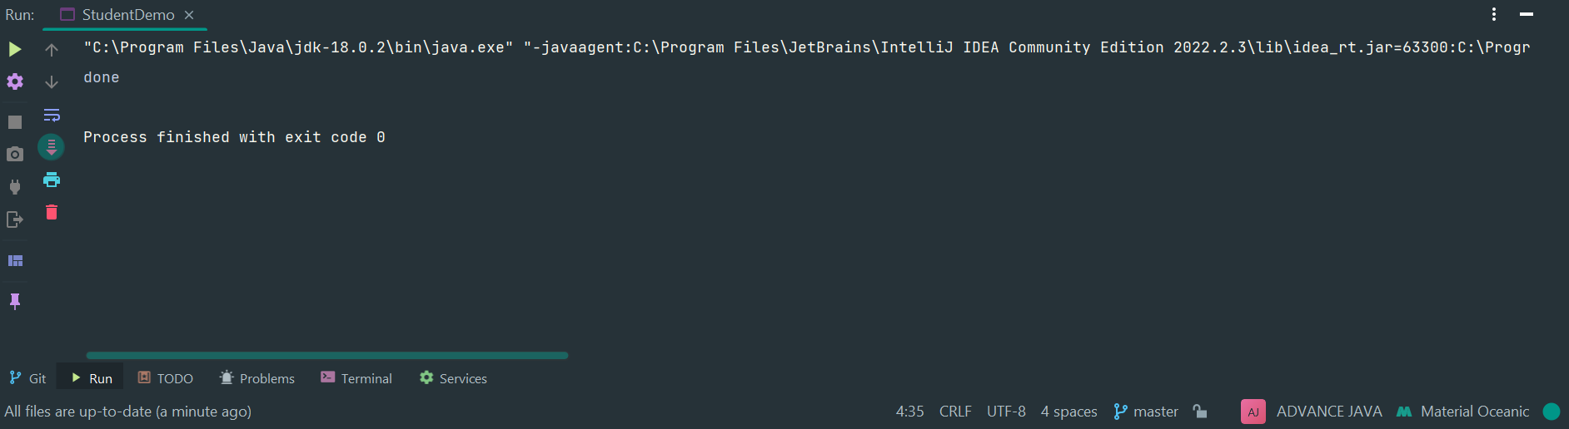

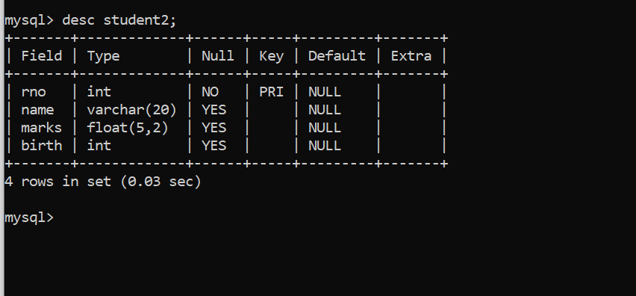

**1 Make a program that displays number of columns present in the given table.**

package Assign;

import java.sql.Connection;

import java.sql.DriverManager;

import java.sql.PreparedStatement;

import java.sql.ResultSetMetaData;

import java.sql.SQLException;

public class Display {

public static void main(String[] args) {

try {

Class.*forName*("com.mysql.cj.jdbc.Driver");

Connection con = DriverManager.*getConnection*("jdbc:mysql://localhost:3306/java", "root", "Prajwal@123");

String query = "SELECT* FROM student2";

PreparedStatement s = con.prepareStatement(query);

ResultSetMetaData rsmd = s.getMetaData();

int column_count = rsmd.getColumnCount();

System.***out***.println("Number of columns in the table : " + column_count);

con.close();

} catch (ClassNotFoundException | SQLException e) {

e.printStackTrace();

}

}

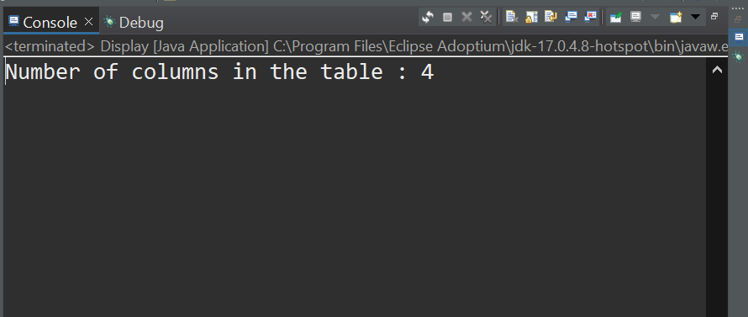

**2. Create a program to call a stored procedure, created to insert student record [ rno, name, marks].**

package Assign;

import java.sql.CallableStatement;

import java.sql.Connection;

import java.sql.DriverManager;

import java.sql.SQLException;

import java.util.Scanner;

public class StoredProce {

public static void main(String[] args) {

Scanner sc = new Scanner(System.***in***);

System.***out***.println("Enter rno");

int rno = sc.nextInt();

sc.nextLine();

System.***out***.println("Enter name");

String name = sc.nextLine();

System.***out***.println("Enter marks");

float marks = sc.nextFloat();

System.***out***.println("Enter DOB");

int birth = sc.nextInt();

try {

Class.*forName*("com.mysql.cj.jdbc.Driver");

Connection con = DriverManager.*getConnection*("jdbc:mysql://localhost:3306/java", "root", "Prajwal@123");

CallableStatement s = con.prepareCall("{ call insert_student2(?,?,?,?) }");

s.setInt(1, rno);

s.setString(2, name);

s.setFloat(3, marks);

s.setInt(4, birth);

int i = s.executeUpdate();

System.***out***.println(i + " rows created");

con.close();

} catch (ClassNotFoundException | SQLException e) {

e.printStackTrace();

}

}

**}3. There is need to store employee information [like :employee id, name, salary, join date] and employee's address information [like : address id, city,country, employee id]. Employee and Address information should be stored in separate tables.  
Create a program which can insert employee and address records. First store employee record  
and then address record. Make sure, if the address record is not saved then employee  
transaction should be rollbacked**

package Assign;

import java.sql.Connection;

import java.sql.DriverManager;

import java.sql.PreparedStatement;

import java.sql.SQLException;

public class EmployeeInform {

public static void main(String[] args) {

try {

Class.*forName*("com.mysql.cj.jdbc.Driver");

Connection con = DriverManager.*getConnection*("jdbc:mysql://localhost:3306/java", "root", "Prajwal@123");

PreparedStatement s = con

.prepareStatement("create table EmployeeInformation(Emp_ID int primary key,name varchar(20), "

+ "salary float(5,2), joining_date int)");

s.executeUpdate();

con.close();

} catch (ClassNotFoundException | SQLException e) {

e.printStackTrace();

}

System.***out***.println("done");

}

}

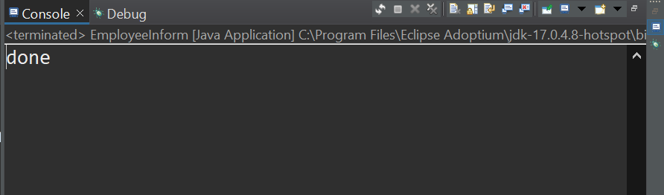

package Assign;

import java.sql.Connection;

import java.sql.DriverManager;

import java.sql.PreparedStatement;

import java.sql.SQLException;

public class EmployeeAddress {

public static void main(String[] args) {

try {

Class.*forName*("com.mysql.cj.jdbc.Driver");

Connection con = DriverManager.*getConnection*("jdbc:mysql://localhost:3306/java", "root", "Prajwal@123");

PreparedStatement s = con

.prepareStatement("create table EmployeeAddr(Add_ID int,city varchar(20), country varchar(20),"

+ " Emp_ID int,FOREIGN KEY (Emp_ID) REFERENCES EmployeeInformation(Emp_ID))");

s.executeUpdate();

con.close();

} catch (ClassNotFoundException | SQLException e) {

e.printStackTrace();

}

System.***out***.println("done");

}

}

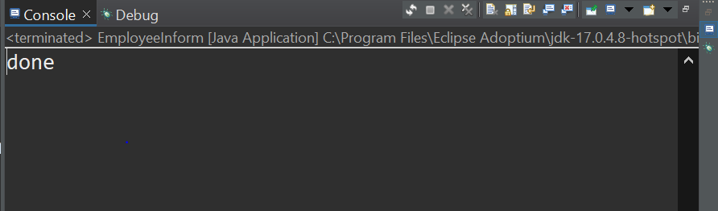

**4. Select the employee records with their address.**

package Assign;

import java.sql.Connection;

import java.sql.DriverManager;

import java.sql.ResultSet;

import java.sql.SQLException;

import java.sql.Statement;

public class SelectAdd {

public static void main(String[] args) {

try {

Class.*forName*("com.mysql.cj.jdbc.Driver");

Connection con = DriverManager.*getConnection*("jdbc:mysql://localhost:3306/java", "root", "Prajwal@123");

Statement s = con.createStatement();

String query = "select * from EmployeeInformation, EmployeeAddr where EmployeeInformation.Emp_ID=EmployeeAddr.Emp_ID";

ResultSet rs = s.executeQuery(query);

while (rs.next()) {

System.***out***.println(rs.getInt(1) + " " + rs.getString(2) + " " + rs.getFloat(3) + " " + rs.getInt(4)

+ " " + rs.getInt(5) + " " + rs.getString(6) + " " + rs.getString(7) + " " + rs.getInt(8));

}

System.***out***.println("==========================================");

rs = s.executeQuery(query);

while (rs.next()) {

System.***out***.println(rs.getString(1) + " " + rs.getFloat(2) + " " + rs.getInt(3) + " " + rs.getInt(4));

}

con.close();

} catch (ClassNotFoundException | SQLException e) {

e.printStackTrace();

}

}

}**5. Select the address of an employee whose employee id is given.**

package Assign;

import java.sql.Connection;

import java.sql.DriverManager;

import java.sql.ResultSet;

import java.sql.SQLException;

import java.sql.Statement;

public class SelectEmp {

public static void main(String[] args) {

try {

Class.*forName*("com.mysql.cj.jdbc.Driver");

Connection con = DriverManager.*getConnection*("jdbc:mysql://localhost:3306/java", "root", "Prajwal@123");

Statement s = con.createStatement();

String query = "select Add_ID from EmployeeAddr WHERE Emp_ID IS not NUll;";

ResultSet rs = s.executeQuery(query);

while (rs.next()) {

System.***out***.println(rs.getInt(1));

}

System.***out***.println("==========================================");

rs = s.executeQuery(query);

while (rs.next()) {

System.***out***.println(rs.getInt(1));

}

con.close();

} catch (ClassNotFoundException | SQLException e) {

e.printStackTrace();

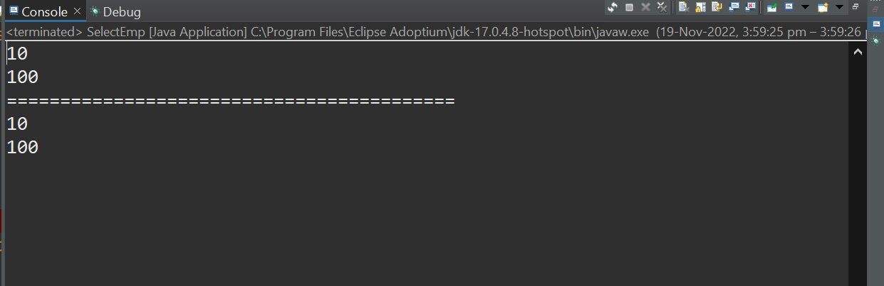

}

}

**}6. Select all the employees who are in the given city**

package Assign;

import java.sql.Connection;

import java.sql.DriverManager;

import java.sql.ResultSet;

import java.sql.SQLException;

import java.sql.Statement;

public class City2 {

public static void main(String[] args) {

try {

Class.*forName*("com.mysql.cj.jdbc.Driver");

Connection con = DriverManager.*getConnection*("jdbc:mysql://localhost:3306/java", "root", "Prajwal@123");

Statement s = con.createStatement();

String query = "select * from EmployeeAddr WHERE city = 'mumbai'";

ResultSet rs = s.executeQuery(query);

while (rs.next()) {

System.***out***.println(rs.getInt(1) + " " + rs.getString(2) + " " + rs.getString(3) + " " + rs.getInt(4));

}

System.***out***.println("==========================================");

rs = s.executeQuery(query);

while (rs.next()) {

System.***out***.println(rs.getInt(1) + " " + rs.getString(2) + " " + rs.getString(3) + " " + rs.getInt(4));

}

con.close();

} catch (ClassNotFoundException | SQLException e) {

e.printStackTrace();

}

}

}

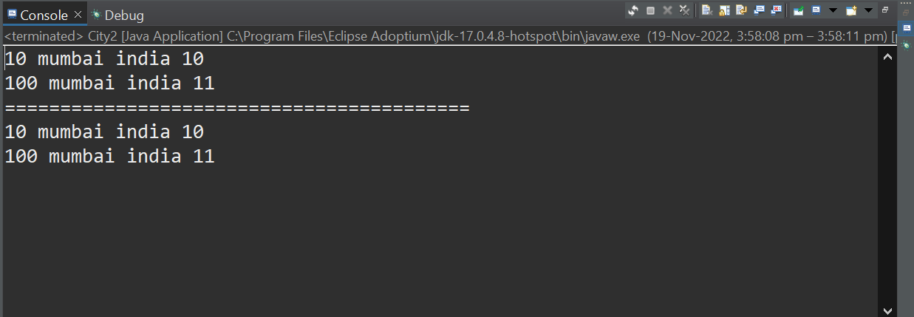

**}7. Select the employee who gets highest salary**

package Assign;

import java.sql.Connection;

import java.sql.DriverManager;

import java.sql.ResultSet;

import java.sql.SQLException;

import java.sql.Statement;

public class City {

public static void main(String[] args) {

try {

Class.*forName*("com.mysql.cj.jdbc.Driver");

Connection con = DriverManager.*getConnection*("jdbc:mysql://localhost:3306/java", "root", "Prajwal@123");

Statement s = con.createStatement();

String query = " select *from employeeinformation where salary=(select Max(salary) from employeeinformation)";

ResultSet rs = s.executeQuery(query);

while (rs.next()) {

System.***out***.println(rs.getInt(1) + " " + rs.getString(2) + " " + rs.getFloat(3) + " " + rs.getInt(4));

}

System.***out***.println("==========================================");

con.close();

} catch (ClassNotFoundException | SQLException e) {

e.printStackTrace();

}

}

.

